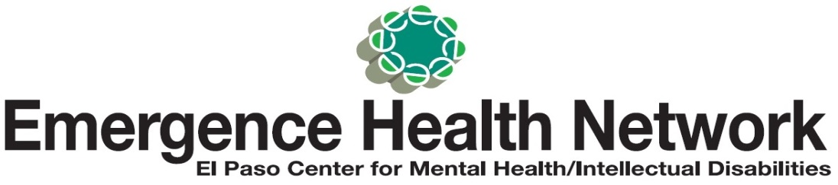___________________________________________________________________________________

or Immediate Release Find us on [Image result for facebook logo](http://www.google.com/imgres?imgurl=http://rmkm.org.in/custom/facebook-logo.jpg&imgrefurl=http://logo-kid.com/facebook-logo-jpg-download.htm&h=296&w=997&tbnid=FkJOuIPnWc2D0M:&zoom=1&docid=_3yuvNHZMMax3M&ei=oHvjVNHCPMKANrrWgeAF&tbm=isch&ved=0CEYQMygTMBM)

Contact: Noreen Jaramillo www.emergencehealthnetwork.org

Director of Communications noreenjaramillo@ehnelpaso.org

(915)342-2464

**Local Agencies Team Up for Mental Health Awareness Month**

**“Because Our Community Matters”**

**Did you know a recent report released by the Tri West Group for the El Paso Behavioral Health Consortium found that in El Paso an estimated 165,000 residents need care each year for mental health or substance abuse disorders… yet less than 15,000 receive the care they need? According to NAMI (National Alliance on Mental Illness) 20% of youth ages 13-18 live with a mental health condition.**

**(El Paso, TX May 2, 2017)** May is Mental Health Awareness Month and that is why Emergence Health Network together with El Paso County Community Support Services and several other local agencies are joining forces to help spread awareness about local resources available to help individuals who need behavioral health services. “The focus this year is not just on adult services but children services as well. This type of awareness is important especially in El Paso because we have a big population of our community that is not seeking the mental health services they need,” said Kristi Daugherty, CEO Emergence Health Network. “If you have a broken leg, you know you have to get help and you know where to go. It’s that type of responsiveness that we need when it comes to getting help for mental illness - for all ages.”

National data shows 50% of all lifetime cases of mental illness begin by age 14. Approximately 50% of students age 14 and older with a mental illness drop of out of high school and 70% of youth in state and local juvenile justice systems have a mental illness. “These numbers are staggering and that is another reason why we need to get the word out about the importance of starting mental health treatment early. It’s like any health condition; early treatment can make a difference. With the proper mental health care, children and adults can lead productive lives,” added Daugherty.

**Mental Health Awareness Month Community Fair/Walk**

**When:** Saturday May 20, 2017

**Where:** Ascarate Park

6900 Delta Drive, El Paso

**Time:** 9 am – 10:0 am - Welcome, speakers, release Butterfly Helicopters

**Butterflies signify Children’s Mental Health Awareness**

**Speakers include El Paso County Commissioner David Stout, Dr. Osvaldo Gaytan, Parent of child w/ mental illness**

10:00 am - Walk begins

11:00 am – 12 pm - Vender booths, music, entertainment, children’s games

C:\Users\noreenjaramillo\Pictures\NAMIEPLogo.color.jpg  Highlands   



     