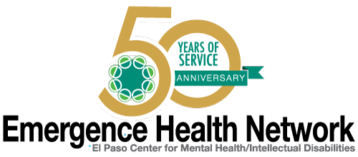
__________________________________________________________________________________
For immediate release Find us on
Contact: Noreen Jaramillo www.emergencehealthnetwork.org
Director of Communications noreenjaramillo@ehnelpaso.org
(915)342-2464

EHN Teams up with Texas Veterans Commission and Texas Commission on Law Enforcement for training to help Vets in Crisis

El Paso Law Enforcement agencies in attendance

(El Paso, TX January 2017) Emergence Health Network (EHN) together with its Veterans One Stop Center is hosting training provided by the Texas Commission on Law Enforcement (TCOLE) for area law enforcement agencies. “As we all know, El Paso has a big military community so this type of training, on how to deal with veterans who are in crisis… is very valuable,” said Kristi Daugherty, CEO Emergence Health Network. “What makes this type of training even more important is that it is tailored specifically for law enforcement personnel.”

The TCOLE training course provides the framework for Law Enforcement officers, and Jailers to have a basic understanding about U.S. Military culture, traumas, trigger and stressors. “Not only are the officers who are taking the course learning how to recognize these signs, but they are learning about de-escalation techniques when encountering Veterans in crisis,” said Erin McGann, Veterans Mental Health Program Coordinator with the Texas Veterans Commission. “This course builds on the crisis intervention training techniques that were taught in the basic Peace Officer licensing academy.”

TCOLE Law Enforcement Training Course on Veterans
Contact is Erin McGann or Dwayne Williams

When: TODAY - Thursday, January 12, 2017
Time: 9:00 am – 11:00 am
Where: El Paso Veterans One Stop Center
9565 Diana Drive, El Paso Texas

