__________________________________________________________________________________
For immediate release Find us on
Contact: Noreen Jaramillo www.emergencehealthnetwork.org
Director of Communications noreenjaramillo@ehnelpaso.org
(915)342-2464

Emergence Health Network Offers help for Suicide Prevention
- Crisis/Suicide Prevention Hotline
- Crisis and Emergency Intake Services
- Counseling Services
- Mental Health First Aid Training
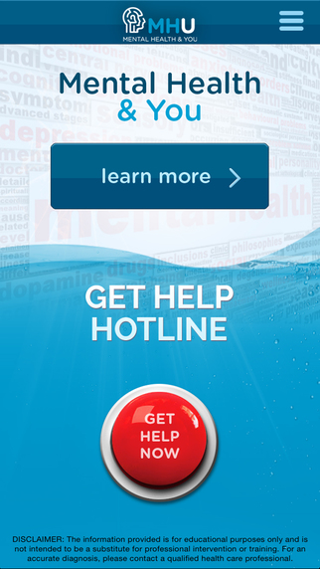
- Mental Health and You Mobile App/Immediate access to trained professionals

Click Video Link to Learn More about New Mobile Application
https://www.youtube.com/watch?v=N50ByIVZ7Yk

(El Paso, TX June 2017) Whether you’re aware of it or not, chances are you know someone
who has been personally affected by a mental health disorder or suicide.

- An estimated one in four adults suffers from a diagnosable mental disorder in a given year
- Approximately 1 in 5 youth ages 13-18 experiences a severe mental crisis in their lifetime
- 90% of people who die by suicide are also believed to have had a mental health disorder

The numbers are staggering, yet only a small percentage of individuals dealing with a crisis will seek help. “This needs to change and that is why Emergence Health Network wants the community to know, help is available. For instance: EHN operates the crisis hotline where trained mental health professionals are available 24/7 to talk to individuals having a hard time coping with a situation. We also launched a mobile application,” said Kristi Daugherty, CEO Emergence Health Network. “El Paso residents can enter their zip code and within seconds they will have access to mental health community resources and if someone they know is going through a mental health crisis they can get help by a touch of a single button. It is technology at its best and it could save lives.”
Learn more about the MH & U App - click on the link below and view the EHN Mental Health and You Video.
https://www.youtube.com/watch?v=N50ByIVZ7Yk
See next pages for additional information on Crisis and Emergency Services

Emergence Health Network Crisis and Emergency Services
Local Crisis Hotline Number 915-779-1800
Toll Free: 1-877-562-6467
- EHN Crisis Hotline Specialists are qualified Mental Health Professionals and have, at minimum, a bachelor's degree in the health and social services field. Supervisors are available 24/7 for additional support as needed. Crisis Hotline Specialists are available to the public, 24/7/365.
- Crisis Hotline Specialists initially provide verbal crisis resolution when they receive a call. Crisis Specialists are trained through their education and trainings to assist in verbal de-escalation and link them to local mental health resources such as Emergence Health Network’s Crisis Intake Unit and Extended Observation Unit or can contact authorities if needed.
National Suicide Prevention Lifeline 1-800-273-8255 (TALK)
- EHN is contracted with National Suicide Prevention Lifeline to take calls in the north to northwestern part of Texas. We also constitute as a roll over center for areas such as Austin and Dallas when their call volume reaches capacity and a crisis operator is not available to answer from the initial designated call center for that area. It is separated by area code, so we receive many of the rural calls to the Lifeline.

EHN Extended Observation Unit
1600 E. Yandell St. Ste. B
24 hour, 7 day a week Crisis Intake Unit
11-bed facility
Up to 48 hours of observation and stabilization from trained mental health professionals

EHN Crisis and Emergency Services
1600 Montana Ave. 1st floor – Monday – Friday 8 am – 5pm
Crisis Intake and Assessments
Free and Confidential Mental Health Screenings
Referral to services
Mental Health First Aid Training (MHFA) offered by EHN
MHFA training is FREE and teaches individuals to identify and respond to a person who is experiencing a mental health crisis. They learn how to help stabilize a person in crisis until they can connect them with the appropriate clinical training. Think of it as being trained in CPR, to help a person having a heart attack – until paramedics can arrive.

Mental Health and You Mobile App https://www.youtube.com/watch?v=N50ByIVZ7Yk
El Paso residents can enter their zip code and within seconds have access to mental health community resources and if someone they know is going through a mental health crisis they can get help by a touch of a single button. It is technology at its best and it could save lives

Warning Signs:
-Inability to cope with daily tasks
-Rapid mood swings
-Increased agitation
-Displays of abusive behavior
-Isolation

Helpful Tips:
Be a support system. Listen to their story and let them know you care. Ask directly about suicide, calmly and without judgement. Let them know their life matters to you. That one conversation could save a life. Reach out for professional help and don't be afraid to talk about what is going on. This helps reduce the stigma associated with mental illness. Encourage the individual to talk with a professional and never be afraid to call 911 if the person is at eminent risk. It is better to be safe than lose another person to suicide.

If you are struggling:
Don’t wait for someone to reach out. Seek mental health treatment; strength comes in asking for help. Treat yourself like you would treat someone else who needs your help.

