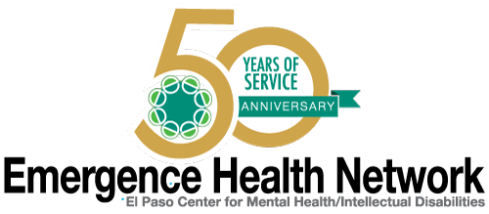
______________________________________________________________________________________________
For Immediate Release Find us on
Contact: Noreen Jaramillo www.emergencehealthnetwork.org
Director of Communications noreenjaramillo@ehnelpaso.org
(915)342-2464

EHN Hosts Concert to Fund Trip to Morgan’s Wonderland Theme Park for residents with Intellectual/Developmental Disabilities

(August 2016, El Paso, Texas) Emergence Health Network will send several EHN consumers with intellectual/developmental disabilities on an all-expense paid trip of a lifetime. “This is one of our favorite times of the year, because we all come together for a very exciting cause. Through our annual Frances Rodriguez Memorial Wonderland Benefit Concert, EHN raises money and then we use 100% of those funds to send some of our IDD clients to the Wonderland Theme Park in San Antonio,” said Kristi Daugherty, CEO Emergence Health Network. “This is exciting because while other theme parks have accommodations for a person with special needs, this theme park was created specifically for individuals with intellectual disabilities.”
EHN is gearing up for its 5th Annual Frances Rodriguez Wonderland Benefit Concert set for Friday August 5, 2016 at Tricky Falls downtown. “It’s a night of live Salsa music, dancing and door prizes. It’s a great time! Last year EHN raised more than $5000 through concert ticket sales and community donations. The money was used to pay for twelve of our consumer’s airfare, hotel, meals, park entry fee and stops at some popular San Antonio tourist attractions such as the River Walk, and historic Alamo,” said Noreen Jaramillo, EHN Director of Communications. “For many of these adults, it was their first time to a theme park or even on an airplane. This year, with the help of our community we will do it again!”
EHN 5th Annual Frances Rodriguez Memorial Wonderland Benefit Concert
When: Friday, August 5, 2016
Where: Tricky Falls, 209 S. El Paso Street
Doors Open: 7:00 p.m.
Tickets at door: $10 - $5 with valid military I.D.
Advance ticket purchase: Call 915-342-2464 or 915-887-3410

