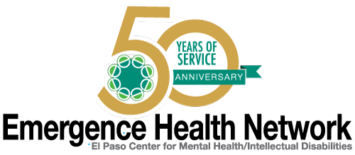
__________________________________________________________________________________
For immediate release Find us on
Contact: Noreen Jaramillo www.emergencehealthnetwork.org
Director of Communications noreenjaramillo@ehnelpaso.org
(915)342-2464

Emergence Health Network Celebrates Veterans Day with “Veterans Appreciation Day and Career Fair”

(El Paso, TX November 8, 2016) Emergence Health Network (EHN), together with our Veterans One Stop Center would like to recognize the veterans in the El Paso community with a Veterans Appreciation Day and Career Fair! “We thought what better way to celebrate Veterans Day than to invite our local Veterans to our new Veterans One Stop Center in Northeast El Paso,” said Kristi Daugherty, CEO Emergence Health Network. “They can get an up close look at the center that was created for them and for those who would like to learn more about higher education or job opportunities in our area…. we will have those resources available for them too.”

EHN will host the career fair with more than 20 area businesses expected to attend. They include Workforce Solutions Borderplex, Union Pacific, and the Border Patrol/U.S. Customs Department, along with representatives from the Texas Veterans Commission and Congressman Beto O’Rourke’s Office who will be available for questions.

“This is a great opportunity for our veteran community and their families. Since EHN is the Local Mental Health Authority we will also offer free confidential mental health screening and service assessments by our EHN Licensed Mental Health Professionals. They served our country, now we need to serve them,” added Daugherty.

Earlier this year, EHN received more than $600,000 in grant money from the Texas Veterans Commission Fund for Veterans’ Assistance and the Health and Human Services Commission (HHSC) for the development of the first of its kind “Veteran One Stop Center” in El Paso. “The Veterans One Stop Center has only been officially open for a few months, but already it is serving its purpose of helping to accelerate access to mental health care and support services for our Veterans. Being able to host our Veterans Day celebration here is just another example of its benefits to our community,” said Noreen Jaramillo, Emergence Health Network Director of Communications.

EHN Veterans Appreciation Day and Career Fair
When: Wednesday, November 9, 2016
Time: 9:00 a.m. – 2:00 p.m.
Where: El Paso Veterans One Stop Center
9565 Diana Drive, El Paso Texas

