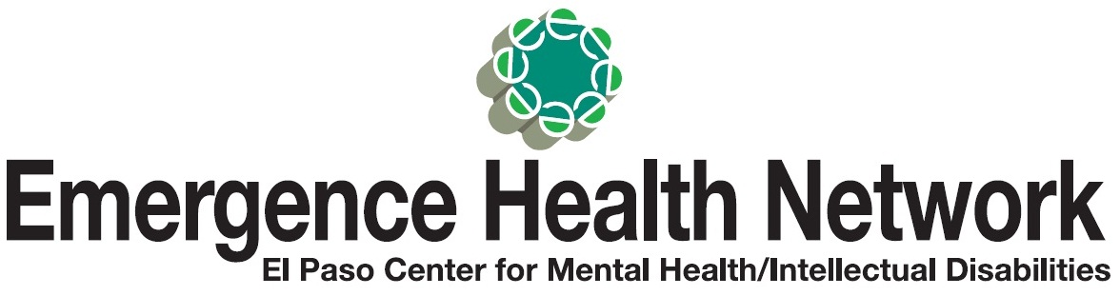
_________________________________________________________________________________________________
For Immediate Release Find us on
Contact: Noreen Jaramillo www.emergencehealthnetwork.org
Director of Communications noreenjaramillo@ehnelpaso.org
(915)342-2464

Emergence Health Network Teams Up with El Paso County Sheriff’s Crisis Negotiation Team Members for
Mental Health First Aid Training
~~ Sheriff’s Richard Wiles available for interviews ~~

(October 20, 2016) Did you know approximately 1 in 5 adults in the United States experiences mental illness in a given year and according to the National Alliance on Mental Illness, approximately…
  - 20% of state prisoners and 21% of local jail prisoners have “a recent history” of a mental health condition.
  - 70% of youth in juvenile justice systems have at least one mental health condition and at least 20% live with a serious mental illness.
  - An estimated 26% of homeless adults staying in shelters live with serious mental illness and an estimated 46% live with severe mental illness and/or substance use disorders.
“Dealing with an individual experiencing a mental health crisis can be challenging, especially for our local law enforcement agencies. So we applaud the efforts of Sheriff’s Wiles and his staff for doing their part to better understand what these individuals can go through and how to respond to them,” said Kristi Daugherty, CEO Emergence Health Network. “We encourage more organizations to do the same.”
Through Mental Health First Aid Training, which is an 8-hour course, participants learn about mental illnesses and how to identify and react to a person in a mental health crisis. MHFA introduces participants to the warning signs of mental illnesses and provides them with the skills to help stabilize a person in crisis until they can connect them with appropriate care. Similar to how CPR training can help a person having a heart attack.
“Our deputies go through a lot of training and being better prepared to respond to an individual in a mental health crisis is also crucial. It is an important tool to have when addressing the needs of our community. Anyone, at any time can feel overwhelmed, depressed or have a hard time coping with a situation so having our deputies go through this MHFA course is important,” said Sheriff’s Richard Wiles, El Paso County Sheriff’s Office.
Mental Health First Aid Training
Sheriff’s Richard Wiles available for interviews
When: Thursday, October 20, 2016
Time: 1:30 pm – 2:45 pm
Where: El Paso Sheriff’s Region VIII Training Academy
12501 Montana, Bld. “B”

