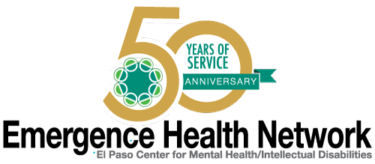
__________________________________________________________________________________
For immediate release Find us on
Contact: Noreen Jaramillo www.emergencehealthnetwork.org
Director of Communications noreenjaramillo@ehnelpaso.org
(915)342-2464

Emergence Health Network Launches Innovative New Mobile App Created to Improve Access and Understanding of Mental Illnesses

Click Video Link to Learn More
https://www.youtube.com/watch?v=N50ByIVZ7Yk

(El Paso, TX October 2016) Whether you’re aware of it or not, chances are you know someone who has been personally affected by a mental health disorder.
- An estimated one in four adults suffers from a diagnosable mental disorder in a given year
- Approximately 1 in 5 youth ages 13-18 experiences a severe mental
- 90% of people who die by suicide are also believed to have had a mental health disorder

The numbers are staggering and go on and on, yet only 41% of adults in the U.S. with a mental health condition received mental health services in the past year. “This needs to change and that is why Emergence Health Network has launched the Mental Health and You mobile application,” said Kristi Daugherty, CEO Emergence Health Network. “El Paso residents can enter their zip code and within seconds they will have access to mental health community resources and if someone they know is going through a mental health crisis they can get help from trained mental health care professional by a touch of a single button. It’s technology at its best and it could really make a difference in our community, maybe even save lives.”
The purpose of the app is to help residents identify the signs of mental illness and direct them to the resources needed to help a friend or loved one who may be in crisis.
Learn more about the MH & U App - click on the link below and view the EHN Mental Health and You Video.
https://www.youtube.com/watch?v=N50ByIVZ7Yk

