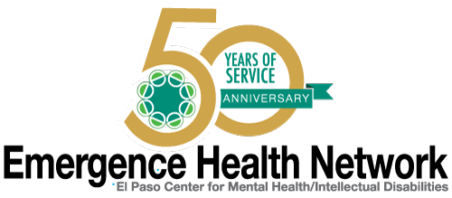
___________________________________________________________________________________
For Immediate Release Find us on
Contact: Noreen Jaramillo www.emergencehealthnetwork.org
Director of Communications noreenjaramillo@ehnelpaso.org
(915)342-2464

Emergence Health Network Recognized as Part of a National Movement to Improve Mental Health Care
~~ Celebrating 50 Years of Service ~~

Celebration includes Commemorative Art Projects Created by EHN Consumers
Visuals for media in EHN IDD Art Class

(El Paso, TX May 3, 2016) You are invited to an EHN Birthday Party!! Emergence Health Network was created in 1966 as a mental health community center in El Paso. EHN was born under an initiative known as the Community Mental Health Act signed into law by President John F. Kennedy in 1963. “The creation of what is now EHN, was part of a monumental movement in the United States which drastically changed the delivery of mental health services,” said Kristi Daugherty, CEO Emergence Health Network. “The law led to the establishment of community mental health centers throughout the country and helped people who were placed in mental “institutions” move back into their communities and back with their families. At EHN, that continues to be our goal today.” EHN provides a wide array of services for individuals with a mental health diagnosis or intellectual/developmental disability with the purpose of helping them function as independently as possible and serve as productive citizens in the El Paso community.
Emergence Health Network is kicking off its Golden Anniversary with the display of “Personal Birthday Cards” created by EHN consumers involved in the Child and Adolescent Mental Health Program (ChAMHPs) and by clients with intellectual/developmental disabilities (IDD) who receive services through our IDD Learning Center. “The art work created by our clients is amazing, but the best part is these cards were created by the very people who benefit from our services. It’s proof that mental health services in El Paso and in our country as a whole has improved since the Community Mental Health Act was first signed,” added Daugherty. “EHN has had several names changes since we were born, but what has been consistent is our commitment to the El Paso community.”
50th Anniversary Birthday Card Celebration/Display
When: Wednesday May 4, 2016
Where: EHN IDD Learning Center Art Class
1477 Lomaland, El Paso
Time: 11 a.m

